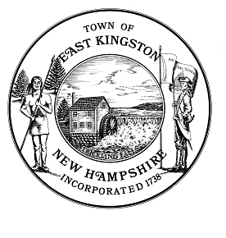
Solid Waste Removal and Recycle Committee Meeting Minutes – January 18, 2023
Members Present: Ron Morales, Dan Guilmette, and Bud Staples Absent: Rob Caron
Attendees: Pete Lachapelle, (WM)
Meeting called to order @ 4:02 PM by Chair Ron Morales
The first agenda item was to elect Committee officers. Dan motioned to nominate Ron as Chair. Bud seconded. Two voted in favor, one abstained. Ron motioned to nominate Dan as Vice Chair, Dan seconded. Two were in favor with one abstaining. Dan motioned to nominate Bud as Recording Secretary. Ron seconded. Two were in favor while one abstained. All nominations carried. Rob Caron continues as Member at Large.
Discussion took place regarding the 2023 increase in processing fee for recycled waste. Pete (WM) mentioned this was due to increased WM costs and higher fuel prices. Ron reported that our budget for 2023 was approved by the BOS as submitted at $313,200. This was a significant increase over last year’s budget due to the increase in processing fee with low expectations of blended value credits due to limited global markets for recycled waste. Pete mentioned WM has started to use and is looking at more domestic mills for recycled material.
Recycled waste was reduced to 28% of total tonnage in 2022, from 316 tons in 2021 to 283 tons in 2022. Solid waste tonnage increased slightly from 715 tons in 2021 to 720 tons in 2022. Bulk waste was reduced from 16.93 tons in 2021 to 13.44 tons in 2022. The decrease in recycled waste was attributed to thinner plastics being used and less paper discarded due to magazines and newspapers having fewer pages or being available online.
Pete distributed an updated sample printout of the 2023-2024 Collection Services Flyer that we reviewed for accuracy. Ron motioned that the Committee accept the WM flyer as submitted with a distribution date by WM to occur in March of 2023. Dan seconded and all were in favor.
A brief discussion took place regarding having a webmaster to post the Committee’s reports and notices as they occur. Dan motioned to have Rob Caron as our webmaster and Bud seconded the motion. All were in favor.
Pete invited the Committee members to a field trip through the WM facilities in Rochester. June 7th was the Committee’s first choice and June 15th was selected to be an alternate date. Pete will get back to us with confirmation of a date and time.
Pete provided a copy of the WM updated insurance policy for Ron to deliver to the BOS office.
The next regular Committee meeting is scheduled for April 19th at 4:00 PM at the Pound School.
Meeting adjourned at 4:50 PM.
William (Bud) Staples
Recording Secretary

