TOWN OF EAST KINGSTON BOARD OF SELECTMEN
SITE VISIT REPORT
June 1, 2023
9 Bowley Road  East Kingston, New Hampshire  1:30PM | Robert Caron, Chair  Joseph Cacciatore, Vice Chair  Robert Nigrello
This report serves to document the observations, findings, discussion, and directives resultant of a site visit to 9 Bowley Road. The purpose of this site visit was to investigate complaints received by the Selectmen’s Office with respect to the appearance of unauthorized land development of property located at 9 Bowley Road, MBL# 11-2-11, in the light industrial district. It was understood by the parties present that Midnight Leasing, LLC proprietors, Peter and Jeff Brown purchased the property for the purpose of operating a mulch manufacturing business; however, at the time of this site visit, no site plan application for the business had been submitted to the Planning Board. Jeff Brown had met with the Planning Board in January 2023 for a conceptual consultation for the purpose of ascertaining whether or not the nature of their business was permitted use for the light industrial zone. The Planning Board had determined that it was and provided guidance on the application process.
Selectmen present: Robert Caron – Chair, Joseph Cacciatore – Vice Chair (1:30-2:00pm), and Robert Nigrello (2:34pm).
Others Present: Town Administrator Grace Ruelle, Conservation Commission Chair Dennis Quintal, Building Inspector Kip Kaiser, Police Chief Mike LePage, property and business owner Peter Brown, and Andy Galloway of Galloway Trucking (1:45pm).
Site visit participants arrived at the entrance to 9 Bowley Road at approximately 1:30pm on Thursday, June 1, 2023. Introductions were made and the site visit participants traversed down the driveway to a newly constructed roadway, and over a newly constructed bridge that expanded over gas line utilities. Copies of the January 19, 2023 Planning Board meeting minutes that provided a record of a conceptual consultation about permitted uses for the property, and maps of existing conditions, and grading and drainage plans dated 2002 were provided at this for reference.
Immediate observations included the extensive width of the newly constructed roadway (approximately 35 feet wide), and a lack of sediment control along the newly constructed roadway.
Mr. Peter Brown was informed the purpose of the visit was to inspect the work being done on the property as there were complaints made alleging encroachment on the wetlands and construction activity without appropriate permits.
Mr. Brown informed the site visit participants the wetlands have all been marked by Mike Seekamp (Seekamp Environmental Consulting), and the site plan for his business New England Outdoor Materials has been drafted by Beals Associates which includes a soils analysis with retention plan. He asserted he believed he could construct a haul road and bridge over the gas lines (as permitted by the utility companies) prior to submitting an official site plan to the Planning Board, which is slated for submission on June 27th in order to get on the July agenda. He stated his next step is to apply for a timber cut permit but needed to construct the haul road in order to get the timber trucks in and out of the property.
Building Inspector Kip Kaiser noted the scope of the road as constructed was greater than a tote road that is typically constructed for timber harvesting. The current roadway as newly constructed appears to be designed as a haul road for future use as part of the bark manufacturing business; not just a tote road to harvest timber. He then asked about the wetlands along the roadway.
Mr. Brown responded the wetlands have not been disturbed as there is still flagging everywhere. He said his son and co-business owner, Jeff Brown, came in with a bush hog machine to cut along the roadway so the timber guys won’t go past the “safety zone” of the wetlands. He stated he was told he could put in a haul road prior to the site plan review work. He went on to explain the site plan will consist of three phases: 1) development of the manufacturing area (this year); 2) develop of a second manufacturing area (next year); and 3) construction of a 40x60 building near the wetlands towards the back of the property (2025).
Conservation Commission Chair Dennis Quintal stated the tote road measurements should be less than 16 feet wide versus the over 30-feet as currently constructed. He noted the road is constructed up against the wetland without any erosion control and that there should be bonding established for the existing town road (Bowley Road).
Mr. Brown stated he was trying to do everything he was supposed to do while he works toward being ready for production in the spring. He plans to install sediment control around the manufacturing area.
Andy Galloway of Galloway Trucking arrived at 1:45pm and was introduced to the site visit party.
Mr. Brown stated he went to the town hall and talked to Mr. Caron on May 11th to inform the town of the construction of the bridge and haul road. The designs for the bridge came from the utility companies and Andy Galloway was brought in to construct the roadway.
Mr. Galloway stated the roadway measures approximately 30 feet wide, and that he will loam and seed the edges. Nothing has washed away since its construction; the roadway has been contained.
Mr. Quintal stated he received numerous calls about the activity on the property. He saw the wetland flags without sediment control and asked the Selectmen for a site visit to investigate. The site plan should have been presented to the town in advance of the work. He expressed his concerns, as Conservation Commission Chair, that the wetlands need to be protected.
Upon review of the plan and the width of the road, Mr. Galloway stated the headwalls are the boundary for the wetlands. Mr. Quintal noted the plan as shared by Mr. Brown does not represent what has been constructed. The 30-foot newly constructed roadway is much larger than the scope of the 16-20-foot roadway as depicted on the plan. The plan will need to be updated prior to submission to the Planning Board.
Mr. Galloway stated the previous owners put in the culverts and headwalls; however, all the woodchips are undisturbed. He would be willing to install silt socks on both sides of the newly constructed roadway if needed.
Police Chief LePage noted the pavement intersecting Bowley Road and Haverhill Road is already getting chewed up by the trucks going in and out of the property. Cones were placed strategically on that intersection to mark those areas and prevent further damage.
Mr. Brown responded there would be no triaxles coming into the property and that he didn’t know he would need to have a road bond. He wants to get the cutting done before the Planning Board meeting in July.
Mr. Kaiser stated constructing a tote road to cut does not require a permit; however, the roadwork that has been completed is more extensive than what is typically allowed for a tote road access to cut.
Mr. Brown stated he thought he was doing everything correctly; Seekamp did the wetland flagging, Mark Jacobs did the test pits and retention ponds, and Doucette did the surveying. He then spoke about the wood/bark mulch/coloring piles which will be surrounded by roads for loader access. The nature of the business is environmentally conscience.
He reiterated his son had a conceptual discussion with the Planning Board, that he (himself) went to the town hall and met with the police chief prior to the commencement of the work; he hasn’t tried to hide anything. He has a timeframe to keep in order to get the property ready for August and eventual operation in the spring.
Discussion then ensued on following up with the complainants. Chief LePage noted that since the property is posted, parties entering onto the property without permission are considered trespassing. He stated the site cannot be seen from Bowley Road – people would need to enter onto the property to see what activity is taking place, and that he has witnessed people drive into the property. He stated trespassing is a misdemeanor offense and trespassers will be arrested. This needs to be communicated to the complainants.
Mr. Brown stated the buffer had been cut a long time ago and he was trying to be pro-active by using a bushhog along the roadway to serve as boundary to the wetlands.
Mr. Kaiser stated tote roads are permitted without a permit unless there is a wetland crossing; then a permit will be required.
Chief LePage noted the property will need to be renumbered due to 911-enhancement requirements. Mr. Brown stated he would like to name the roadway Mulch Road but that this was discussion for a later time. He then asked if there was a buried powerline requirement as this could be an issue at phase three of the project with respect to running power to the proposed building and crossing the gas lines. He was informed all site plan review regulations are posted on the town’s website and that the Planning Board would be able to address this question.
Mr. Kaiser reiterated the roadway was built with future use intent (more than just a tote road to access timber) without a site plan on the books. As Building Inspector, he directed the intent to cut request/permit include submission of wetland/site work plan; otherwise, the only two options to address the overdevelopment of the roadway and lack of erosion control are to either stop the development activity or take corrective actions.
Mr. Quintal brought up the need to bond the road, noting the intent to cut permit would result in a number of trucks driving up and down Bowley Road. Mr. Kaiser agreed a bond should be put in place but this would be at the discretion of the Selectmen.
Mr. Galloway spoke to installing a silt sock along the roadway prior to a heavy rain.
Mr. Brown noted the roadway from Bowley to the bridge has not been touched. The haul road is for loggers.
Mr. Quintal recommended Mr. Brown go before the Planning Board before going any further.
Mr. Kaiser reiterated the roadway was constructed for use for the final development of the property as it was constructed to more than what was needed for a tote road to harvest timber.
Mr. Quintal agreed and stated the road should have been developed in two stages: one as a tote road for timber harvesting, and then as a haul road for the business. He then stated the wetlands along the roadway that have already been flagged need to be protected. Mr. Galloway agreed to install erosion control materials.
It was noted that the roadwork as completed thus far goes beyond the scope of pre-approval work; it goes beyond the Planning Board approval threshold. The road was constructed as a haul road to save money; however, in doing so, the application/approval process was not strictly followed. Mr. Brown believed the scope of the work completed thus far was okay.
Mr. Kaiser stated the section of the plan needs to be updated to reflect the actual construction that has taken place and this plan needs to be submitted with the timber cut permit request. A bond needs to be put in place to cover Bowley Road repairs due to trucking activity (more information about this process shall be directed to the Town Administrator).
Mr. Brown stated the roadway needs to be constructed an additional 100 feet to access the timber on the property. Mr. Galloway, Mr. Kaiser, and Mr. Quintal inspected the remaining area to be filled to complete this part of the roadway.
Mr. Brown spoke to the remaining party about the mulch manufacturing process: wood chips and tree bark are source from sawmills and tree companies, trucked in (sometimes logs are used) during the year. The wood chips and tree bark are mixed, ground and colored, placed in piles over the winter month for color absorption/aging purposes, then shipped out in the spring and summer months.
Upon return of all parties present, including the arrival of Mr. Nigrello, the following expectations were noted to ensure all parties understood the terms moving forward:
- Erosion control would be immediately installed.
- The remaining 100 feet of roadway (to the loam pile) could be completed.
- The remaining 100 feet of roadway shall narrow from 35 feet wide to 24 feet wide (at the point of the poorly drained soils).
- A plan showing the sediment control, existing and proposed conditions be submitted with the timber cut application.
- Expectation for the potential bonding of the road (Bowley Road) to be determined by the Board of Selectmen.
- Provide copies of the utility crossing approvals to the Board of Selectmen.
- Provide copies of the bridge construction permits to the Board of Selectmen.
Mr. Quintal asked for permission from Mr. Brown to be able to enter onto the property to conduct inspections of the work throughout the approval and construction process.
Mr. Brown agreed with the condition Mr. Quintal is accompanied by himself or his son.
The site visit ended at 2:45pm.
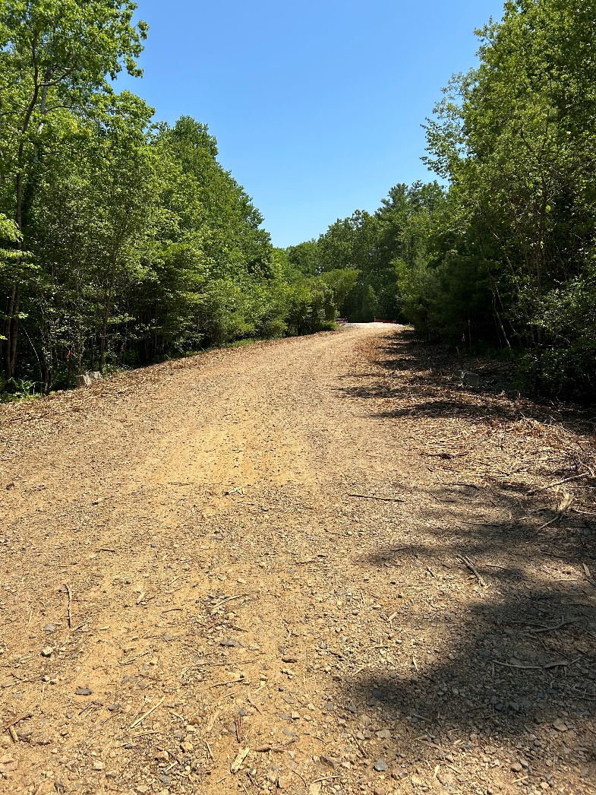
SUPPORTING PHOTOS DOCUMENTING THE OBSERVATIONS OF THE SITE
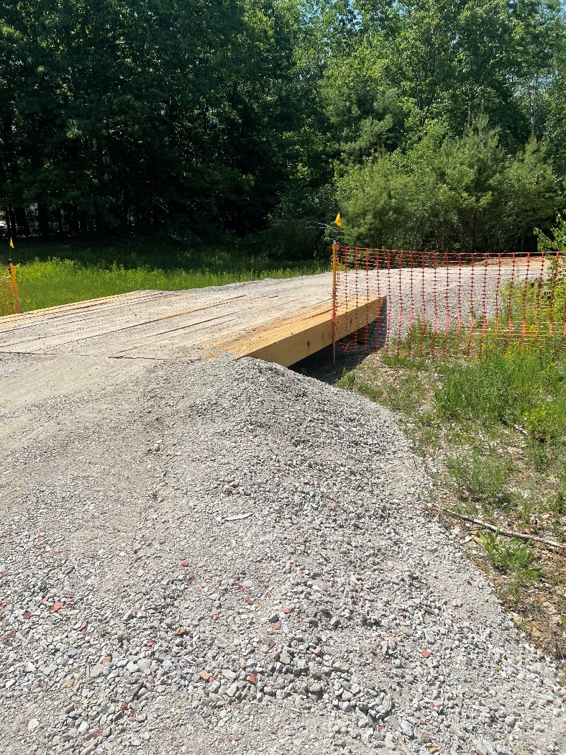
(Left to right: entrance to 9 Bowley road showing no changes to the existing portion of the roadway; newly constructed bridge over gas pipeline)
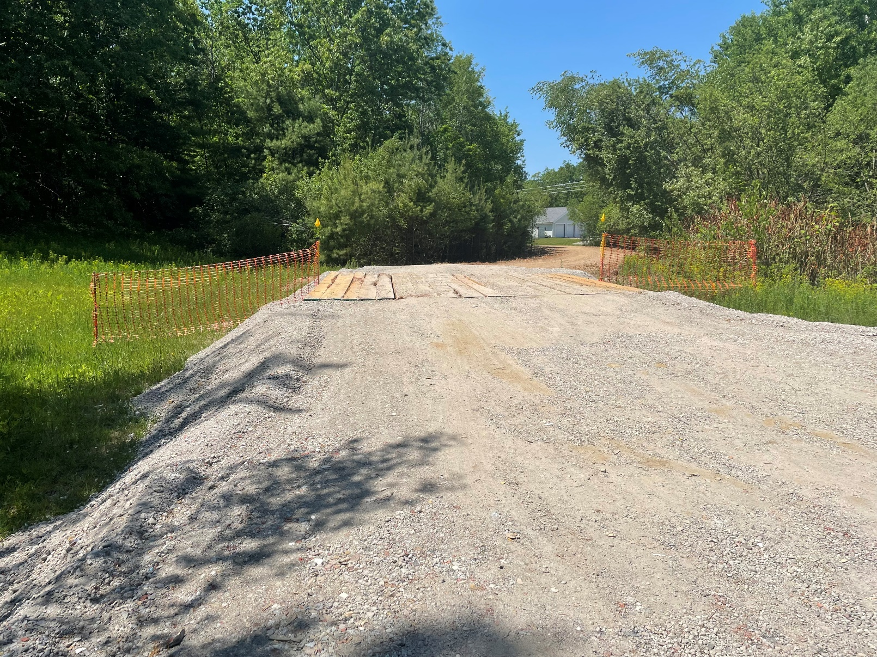
(Newly constructed roadway view from inside the parcel to the entrance road showing the newly constructed bridge over the gas pipeline, the extensive width of the roadway, and lack of sediment control along the roadway.)
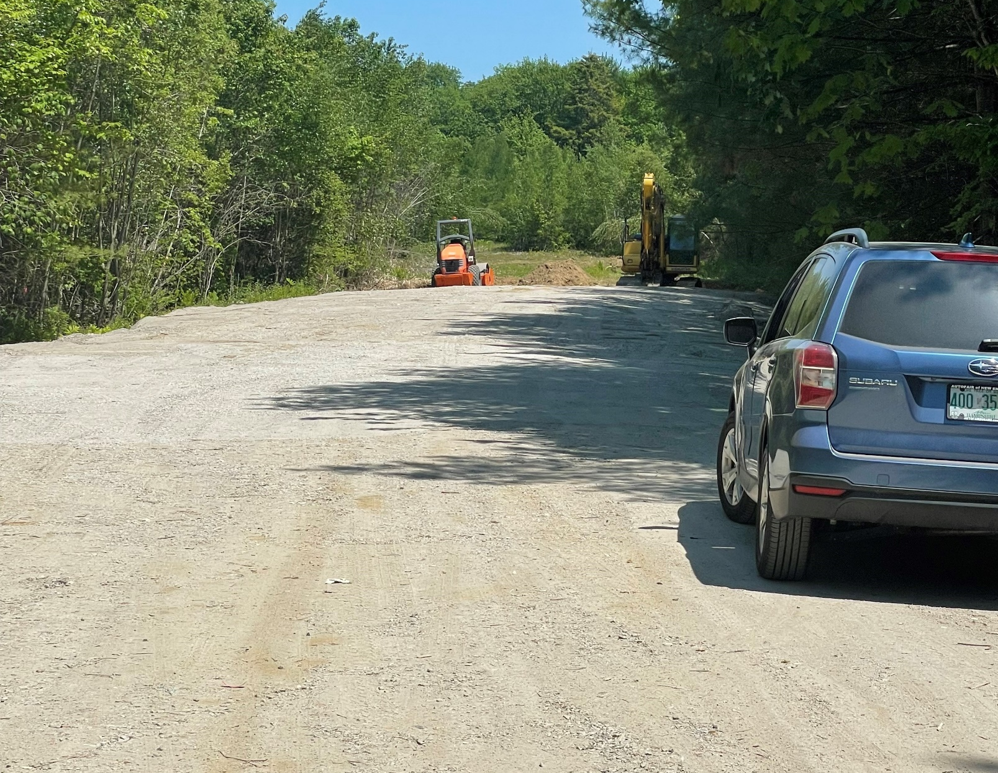
(Edge point of newly constructed roadway where permission was sought to extend an additional 100-feet. The portion to be constructed shall narrow to 24 feet at the point of the poorly drained soils.)
Report prepared by Catherine Belcher.

Joseph Cacciatore |  | Robert A. Caron |  | Robert L. Nigrello

